Walking Robot

Diggy is a robot that can walk on a 2D plane (x, y coordinates). It can only perform following operations:

1. **R** : Turn 90 degree on right (clockwise).
2. **L** : Turn 90 degree on left (counterclockwise).
3. **WN** : Walk forward **N** units in the direction robot is facing. For example, **W2** means robot walks 2 unit point forward

Your need to create a command-line based script in any programming language of your choice. The script accepts a command line argument as an input string of the current position, direction and walking code and print out the result of the last position of the robot.

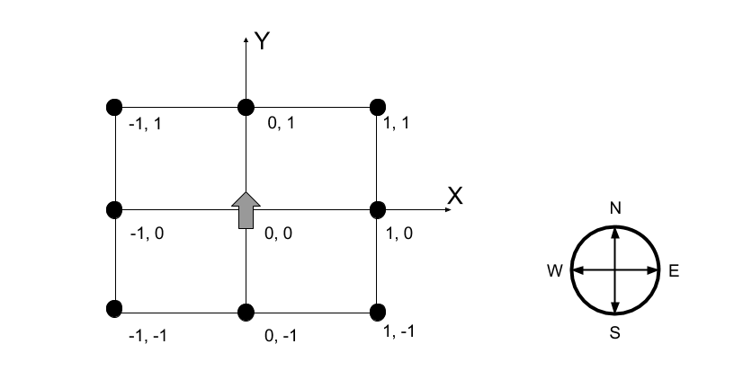

# Input Format

**X Y D S**

X = Current X position

Y = Current Y position

D = Current direction robot is facing (North, East, South or West)

S = Walk string

# Output Format

**X Y D**

X = Current X position

Y = Current Y position

D = Current direction robot is facing (North, East, South or West)

Your script must take these inputs from command line.

# Example

$ php diggyWalkingRobot.php 5 2 SOUTH RW2LW4R

$ 3 -2 East